IM Requirements
High Level Architecture

Document Version 1.1
June 18, 2005

Table of Contents
Table of Figures 4
** Document Version Information 5
Release Notes 6
Version 0.4: 06/03/05 6
Introduction 7
Level of Detail in this Document 7
Scope: Areas of Concentration and Gaps 7
IM Overview 8
Inventory Management System: What does it do? 8
Inventory Management Phases and Iterative Goals 8
IM Service Provisioning 10
Where Does IM Fit Into The MK Architecture? 10
Order Management System 11
IM Business Rules Management System 12
BRMS for Inventory Management 12
Releasabilty Rule Dimensional Hierarchy Focus 13
Inventory Management System Analytical Engine 14
Releasabilty Rules – Venue Dimension 15
Internal Rules Design for Inventory Management Analytical Engine 16
IM Repository and Record 17
IM Records 17
IM Record Content 18
IM Services 20
Set of IM Service Functionality 20
Record Locking Requirements 20
Transaction Tracking Requirements 20
IM Record State and Descriptions 23
IM Service Record States Flow and Resulting States 23
Appendix 25
IM Determine Analytics Engine Method Processing 25
IM Order Release Service: Venue Group Availability 26
IM Rules Service: Execute Rule 27
IM Service: Determine Fact Data Availability 28
IM Determine Data Availability Method Processing 28
IM Determine Imputation Services 29
IM Determine Imputation Processing 29
IM Determine Re Run Method Service 30
IM Determine Re Run Method Processing 30
IM Service: IM Update Record Method 31
IM Update Method Processing 31
IM Service: IM Search Method 32
IM Search Method Processing 32
IM Scheduling Process 33
IM Scheduling Engine Processing 33
IM – Interfaces 34
IM Interfaces for InfoScan MK 1 34
IM – Appendix 2 35

Table of Figures
Figure 1: Where Inventory Management System fits into OMS Architecture 11
Figure 2: Inventory Management Analytic Engine Diagram …………………………………………………..

Figure 3: Inventory Management System Detail Flow Diagram ………………………………………………

** Document Version Information

Document Version Information
Version | Description of Changes | Date | Author
0.1 | Initial draft | 05/05/05 | Ursula Phoenix
0.2 | Updated Table of Contents and Service Listing  Updated BRMS for IM RR types | 05/15/05 | Ursula Phoenix
0.3 | Retrofitted Services and Methods  Updated Phases and Iterative Goals | 05/22/05 | Ursula Phoenix
0.4 | Updated IM Architecture  Updated preliminary conditions for IM statuses  Updated Service Functionality and Methods | 06/03/05 | Ursula Phoenix

Release Notes

Version 0.4: 06/03/05

Updated Preliminary Conditions for IM Statuses and Services
Added IM Phases and Iterative Goals

Introduction

This document details the requirements, required functionality, and high-level architecture required related to the Inventory Management System (IM). This document is intended to be used by the development team during the creation of the detailed design documents and is also intended to be used for the development of test cases.

Level of Detail in this Document

This document accomplishes the documentation of the v1.4 Iteration of the Inventory Management System requirements and high level design architecture. Some of the requirements are additionally captured in the Inventory Management System Requirements and Specification Document. The next version of this document will include more implementation details and further definition of interfaces. As more information is gathered the details of the Inventory Management System will be filled in. This document is a “work in progress”.

Scope: Areas of Concentration and Gaps

This iteration of this document concentrates primarily on the needs of InfoScan MK 1 of the OMS. The Inventory Management requirements will be expanded as more information is known about the IM Analytical Engine Rules, Meta Data (MMS), Interfaces and other back-end dependencies. This document will be updated again when additional back-end requirements and information is provided.

IM Overview

Inventory Management System: What does it do?
Inventory Management is a repository (partitioned metadata repository) that captures the information about the inventory used to fulfilling an order. Also Inventory Management is a number of services providing the control of the movement and staging of the metadata within an operation (Order Occurrence) and processing the associated transactions. The goal is to positively impact the Order Control File that is handed off from OMS to the DMC or Data Mart Creation Orbiter File in the DMC Arrival and Data Stage Function. The handoff between OMS and the actual order fulfillment process will now include strong QC checks that have been enforced prior to an order occurrence or BOM creation.

The architecture required will allow the IM to detect and track changes that will impact the order. The detection will happen prior to building or running of an order. The IM will detect and track changes for the following: raw data availability, partial or incomplete inventory data loads, imputed data percentages and tolerances, dimensional data changes, factual data changes and other inventory requirements to fulfill each order.

The Dimensional Management System (DMS) will provide a visualization tool that allows users to do different actions with the available data. Usually there is one hierarchy per dimension in any order.

Inventory Management Phases and Iterative Goals
Phase 1, Iteration 1 Order Release

- Dimensional Hierarchy – Venue Group(s) availability
- IM will make the decision to release or not release an order based on the order specifications and the availability answer it receives back via a service. The IM service will call FDW’s File Management Systems abstractions. This determination will be made through information captured by IM. For simplicity, we can refer to the service as the “Order Release Service”. For the first iteration of phase 1, IM will determine the availability of a Venue Group(s) and associated Fact data is available for the order utilizing the Order Release Service.
- TBD: Order Release Phase 1, I1 and I2 may need to be combined in part or wholly due to critical dependencies. For example, a venue group may or may not be available for a particular client

Phase 1, Iteration 2 Order Release

- Dimensional – Item(s) availability
- Dimensional – Consumer(s) availability (DMS TBD)
- Dimensional – Measure(s) availability
- Dimensional - Time availability
- Dimensional – Multiple (combined) availability (Multiple versions of a hierarchy are made available and is related to a specific dimension)
- Dimensional – Flexible (custom) availability
- Dimensional – Causal/Event availability

Phase 2, Iteration 1 Releasability Rules
- Applied Measurement Packages to Order
- Applied Measurement A la Carte to Order
- Applied RR that are Product Specific (Info Scan POS, Panel, TRV)
- Applied RR that are specific to Client/Customer types
- Applied RR that are specific to User types
- Applied RR that are specific to Order Type (Full, Partial,
- Applied RR that are specific to Order Status (Update, Run, Re-Run, Flexible Restatement)
- Applied RR that are Orders that require historical or back data (pre dates 5 year mark)
- Applied Rules to other scenarios still to be uncovered

Phase 3 Iteration 1 Changes in Dimensional Data
- As it applies to all Order and BOM types and statuses
- Impact on applicable Measurements and Measurement Packages
- Existing or New Order Update
- Existing or New Order Update but Hierarchical Changes

Phase 3 Iteration 2 Changes in Fact Data

- As it applies to all Order and BOM types and statuses
- Impact on applicable Measurements and Measurement Packages
- Existing or New Order Update
- Existing or New Order Update but Fact Data Changes

IM Service Provisioning

In order to provide an appropriate level of abstraction, an IM service using the defined EJB Service Architecture will be used (See Service Architecture Document). This document defines the requirements and processing required for the high level externally exposed methods of this service that are anticipated to be needed to support the processing required by the OMS as detailed in the OMS Functional Specification and Inventory Management Requirements Document. This document doesn’t detail the EJB Service Architecture this is documented in the technical design document.

The SOA – Service Oriented Architecture includes:
- Loosely –Coupled: Web Services
- Tightly – Coupled: JDBC

Where Does IM Fit Into The MK Architecture?

The figure below depicts where IM fit into the architecture based on current knowledge. At this point, only the interfaces with the OMS are relevant to InfoScan MK 1. The other interfaces are based on composites of conversations and meetings and are likely to change prior to implementation.

Order Management System
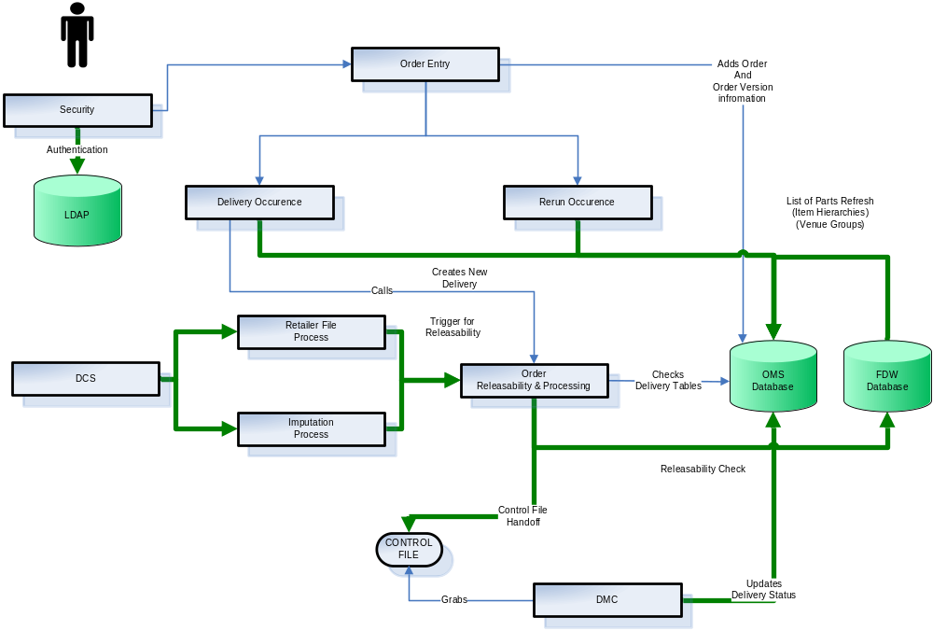

Figure 1: Where Inventory Management System fits into OMS Architecture

IM Business Rules Management System

This section of the document describes how the internal rules will be designed in Business Rules Management System for Inventory Management/OMS during InfoScan MK 1. The internal rules design guide posts and guard posts for a pass or fail criteria. The pass or fail criteria is against a Update, Run or Re Run matrix for each Occurrence (BOM) and Order. Initially during InfoScan MK 1, the rules driving the methods will be housed in the beans. Eventually, the rules for each service will be migrated to the BRMS.

BRMS for Inventory Management

The IM will manage the OMS rule set that determines data availability and changes to that data that affect the order. InfoScan MK 1 addresses Releasability Rules, Scheduling Rules and the Process Plan Rules. The OMS Scheduler requirements and functionality document will lead the content of this document. The IM record will triggered by the OMS scheduler when a BOM request is present. The process plan rules will be a subset of the method characterization to be outlined in this document. Addition information is being gathered from the business to define what thresholds and parameters will dictate the relevancy of the rules. Thus, in this document the Releasibility Rule Set is uncovered and detailed.

Releasability Rule Type | Iteration | Description and Parameters
Info Scan – Dimensional Data Availability | InfoScan MK 1 | Rules that determine if the data is available and if it constitutes a full or partial order release
Info Scan – Fact Data Availability | InfoScan MK 1 | Rules that determine if the data is available and if it constitutes a full or partial order release
Info Scan Data Change | InfoScan MK 1 | Rules that determine what changes have occurred in the data – Baseline is the order data parameters and attributes
IM- OMS Compliance Reporting | InfoScan MK 1 | Reports that show the results of the Rules that track the number of occurrences that pass or fail the OMS quality control parameters
Info Scan Contractual | InfoScan MK 2 | Rules that guard Private Label UPC Data – IRI Cannot Display
CDM – Client Delivery Management | InfoScan MK 2 | Rules that guard CDM Private Label UPC Data – Keycats
Info Scan – DeCA Causal | InfoScan MK 2 | Rules governing Census Only DeCA outlet where causal measures have been added
Info Scan ODF | InfoScan MK 2 | More Research needed

Releasabilty Rule Dimensional Hierarchy Focus

 Issue: The Releasability Rules for IM for InfoScan MK 1 is going to be focused on the Suite of products Info Scan Delivers and the Dimensional Venue – Hierarchy Venue Group (per IM Requirements Document). However, it still needs to be determined for implementation, if we need to also set rules around the other Dimensions and Hierarchies and potential DataMart Creation Deliverable Types.

Inventory Management System Analytical Engine
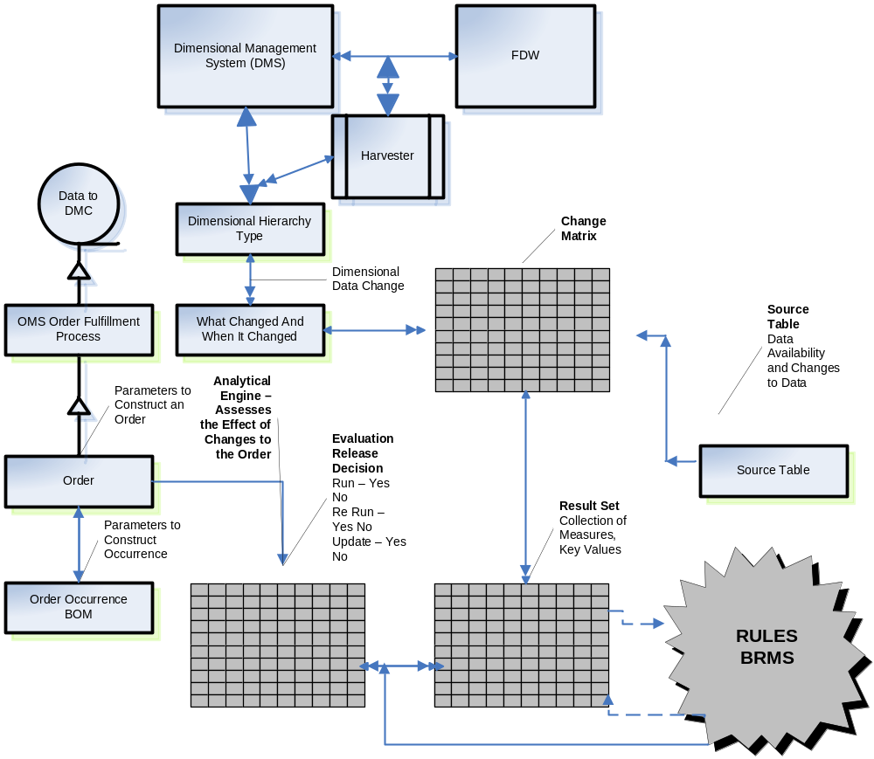

Figure 2: Inventory Management System AE Diagram

Releasabilty Rules – Venue Dimension
The Rule set is in relation to the Venue Dimension Hierarchy. It will include the additional information detailed in the Rule Set. These Rule Category Sets are in scope for InfoScan MK 1 of IM/OMS. There are other rules that will be uncovered as a subset of these general rules or completely new/different rules that what is listed in the table below.

Rule Category Sets | Description
Geog/time/intermediate measure releasability | Rules associated with data that is marked n/a, truly, in the sense that calculated intermediates may not be present at all
Geog/time/final measure releasability | Rules created by S&P and utilizes the geography releasability files created by the projections interface
Product/geog/releasability(1) | Rules associated with product attributes and geogs; hard-coded in current infoview build logic
Product/Geog/releasability(2) | Rules associated with retailers who do not want the sales information for their private label or generic brands made known in certain situations. (May constitute a “Custom Releasability Rule)
Product/Geog/releasability(3) | Rules based on the lowest product Hierarchy level in which such information is viewable and can be a function of who is looking (roles and responsibilities/User group) at it and what the venue group is.
Measure Specific Releasability | Rules that determine which product hierarchy levels are releasable for measures (Example: For Measure A, releasable above level = TYPE, non releaseable <=TPE). Rules are in the measure table to determine.
Product Masking Releasability | Rules that affect subsets of products, geogs, measures; utilized in the UK; determined by service manager
Scoping | Rules filtering what specific clients can see from the pool of available information. Facilitated by print flags in the product hierarchy
Venue Hierarchy Data Availability | Rules that check if the venue data is available, and determine the impact on the order
Venue Hierarchy Data Changes | Rules that check if the venue data has changed, and determine the impact on the order
Venue Hierarchy Data Imputation | Rules that check if the available data is overly imputed based on measures and determines the impact on the order
IM Compliance Reports | Rules that determine the percentage and count of total order events that were re-run, run and updated met the QC standards or fell below QC standards
IM QC Standards | Rules that set the QC standards for IM/OMS
Client Delivery Management | Rule that govern the clients restrictions in the affected Product keycats

Internal Rules Design for Inventory Management Analytical Engine
Dimensional Data Guard Posts
- Dimensional information must be represented in the parser before internal representation of rules can be generated.
- Dimensional information must be normalized to facilitate source/application cube comparisons.
- Dimensional information normalization must occur after data partitioning has occurred, so normalization will most likely occur twice since dimension normalization will occur on each individual partition.
- Optimization can only occur after all rules have been internally represented.
- Each rule must be internally represented in two parts
- Dimensional information
- Source Cube
- Application Cube
- Execution Course and Information
- The source and target cubes will be represented in a cube table
  - The hierarchical information in the cube table can be represented in one or two ways:
    - Symbolically
    - Physically represent all dimensionality with consistent type of bit structure
- The parser will attempt to build a representation of each source and target cube by referencing actual dimensional information
- Dimensional information must be derived from the data source definitions in the script
- The parser will have to dynamically generate a dimensional data reading scheme based on the schema definition
- Dimensional operators will have to be supported within the parser as well – same operators used by the ilogs – brms tool.
- The execution information will have the following elements:
  - Aggregation Operator
  - Algebraic expression
    - In the presence of the aggregation operator, is an argument to the aggregation operator
    - The algebraic expression will be represented as either:
      - A String Literal
      - An Expression Tree
    - There will be arguments the algebraic expression that are measures that will have some dimensionality
    - Dimensional information will show how the measure is derived from one of the cube table entries; the dimensionality must be resolved to be able to relate it to the cube entries
    - The dimensionality may be a subset of the cube table entry
    - This dimensionality will also have to be represented as either:
      - A String Literal
      - An Expression Tree
- The risk of this proposal is compile time considerations, cube trees will be arbitrary based on the order of the measures being processed.

IM Repository and Record

IM Records

IM records will be stored in one or more Oracle tables. The schema of these tables will be defined in the architecture design document based on the contents described below. The intent of the IM record is to check the information about the data that is needed by the Order or Occurrence (BOM). In checking that information the IM will determine if there is a pass or fail criteria met to Run, Re-Run or Update the Order or Order Occurrence(s) BOM(s).

Some of the standard requirements that are echoed from the BOM can in part relate to the IM:

- Information should not be duplicated in the IM record that can be obtained by the DMC or other OMS users else where unless there are performance or other reasons to duplicate specific information. Where possible, a key to one or more database records that contain the information needed to receive the IM record will be provided and they will be expected to access the records of interest using the keys.

- Additional fields will only be added to IM records once a specific use is identified. Although at this point, assumptions could be made about certain types of information that may be needed in IM record, they won’t be added to IM records until a specific need is identified.

- The physical schema that supports logical IM records should be extensible so that it supports the inclusion of additional fields.

IM Record Content

IM records will contain the following information from the Order Schema intersection tables. Those Tables are Order, Order_Version, Delivery, Delivery_Component, Order_Venue_Group and Venue_Load_Status. Additional attributes and table elements may be added as the schema changes. The purpose is to complete the record with the necessary information to obtain a green light to run, rerun or update the order and or occurrence (BOM). The OMS will be the facility in which data marts are requested.

Element | Description | Field Attribute/Comment
IM ID | PK Unique ID of IM | Auto – Number created when IM record is written
IM Order ID | FK from Order_TBL ID of BOM parent if the BOM was rerun – set to NULL if the BOM isn’t a rerun | Auto Number This is the ID of the original parent (i.e. if a rerun is rerun, this will contain the original parent of the rerun and not the rerun itself)
IM Order BOM Occurrence ID | FK Unique ID of order that the BOM came from (key into order tables) FK from intersection table (ORDER_BOM_TBL) | Auto Number This is the ID of the Child of the Original parent. No other order information will be included as this can be looked up and may change from the time that the IM has been created
Client ID | FK Unique ID of Parent_Child Account from Client _TBL | AutoNumber Assumed to be a key into whatever will store this information (ideally CRM)
Client Name | Name of client (Parent_Child Account Name) from Client_TBL | Although can be discerned from the client ID, for efficiency purposes re OMS functionality, should be included here also
Retailer ID | FK Unique ID given to Retailer in the Venue Hierarchy | AutoNumber The next level down in the Venue Hierarchy
Retailer Description | Description of the Retailer Information | VarChar (50)
Store ID | FK Unique ID given to Store in the Venue Hierarchy | AutoNumber – the next level down in the Venue Hierarchy
Store Description | Description of the Store Information | Var Char (50)
Version ID | FK – Version Control File ID | Auto Number
Receipt Date | Date of Receipt of BOM – IM Trigger | IRI Standard VarChar 10  (XX/YY/ZZZZ)
Receipt Time | Time of Receipt of BOM- IM Trigger | IRI standard
Imputation Type | Type of Imputation – would include attribute and entity indicators | VarChar (50)
Imputation Type % | Percentage Imputation Threshold allowed (Parameters) | AlphaNumeric (10)
Dimensional Mod Type | Type of Dimensional Modification | AlphaNumeric (10)
Dimensional Mod Reason | Reason for Modification to Dimension | AlphaNumeric (50)
Initial Load | Type of Load | AlphaNumeric (50)
Re Load | Yes or NO | AlphaNumeric (50)
Transaction Date | Date that Order is Due for Delivery | IRI Standard
IM Status | Status of the IM. See IM Record States and Transitions section below for a description of the IM states and transitions | TBD
BOM specific Fields that my be relevant
Planned Run Date | Date that IM was supposed to be run | Ascertained from the time dimensions. If the IM is for a rerun, set to the date of the rerun
Actual Run Start Date and Time | Date and time that the IM was actually fed to the DMC for processing | Assumes that a back-end process that has yet to be identified will set this field - no firm requirement for this – seems like something that would be useful
Actual Run End Date and Time | Date and time that the processing of the IM ended. | Assumes that a back-end process that has yet to be identified will set this field- no firm requirement for this – seems like something that would be useful
Rerun Reason Type | Indicates a reason for a rerun if this IM was rerun. Has following values:  - NOT-RERUN: The IM is not a rerun (default state upon IM creation)  - OPERATIONAL-RERUN: The IM was rerun for operational reasons  - DATA-RERUN: The IM was rerun for data reasons
Rerun Reason Subtype | Code that indicates why the IM AE was rerun. Is a function of the rerun reason type (i.e. different subtypes based on the type value). The following examples were provided in the Quotes and Orders Requirements Document  OPERATIONAL-RERUN Subtypes:  - Network, code, environment, platform  DATA-RERUN Subtypes  - Dictionary, Modify Fact Data, Replace Fact Data, Add Fact Data, Modify Dimensions | Only set when a IM is rerun. Set it the original IM that was rerun – not the actual rerun IM.
Rerun By | The ID of the user who initiated the rerun
Rerun Comment | The comment entered by the user who initiated the rerun
IM Content Start Date | Start date of IM content
IM Content End Date | End date of IM content

Issue: IM Record Content
  - It is assumed that as more as more information is gathered to define the BOM record the IM Record Content may change. Also, the more that is known about the back-end processes that touch the IM records, the record content of IM records will need to be enhanced.

IM Services

Set of IM Service Functionality
The following set of IM Service Functionality that needs to be provided has been identified. IM service methods for this functionality are described for each of these functional areas.

Service Functionality/Method | Description
IM Analytical Engine | Executes the rules that determine if occurrence or order should be run
IM Order Data Availability | Determines data availability required for order
IM Dimensional Data Changes | Determines dimensional data changes
IM Factual Data Changes | Determines factual data changes
IM Data Changes Tracking | Traces the Changes in the Dimensional and Factual Data
IM Search | Provides for generic searching for IM records
IM Compliance Reporting | Provides for the reporting for compliance thresholds. )

Record Locking Requirements

Issue: The method of conflict resolution throughout the OMS and related systems has not yet been decided on. The IM service methods will need to be cognizant and abide by whichever method is decided upon.

Transaction Tracking Requirements

Issue: System-wide requirements for transaction tracking have yet to be provided. The IM service methods will need to abide by these requirements when they are finalized.

The following diagram depicts the Process Flow for Managing Order Fulfillment for IM.

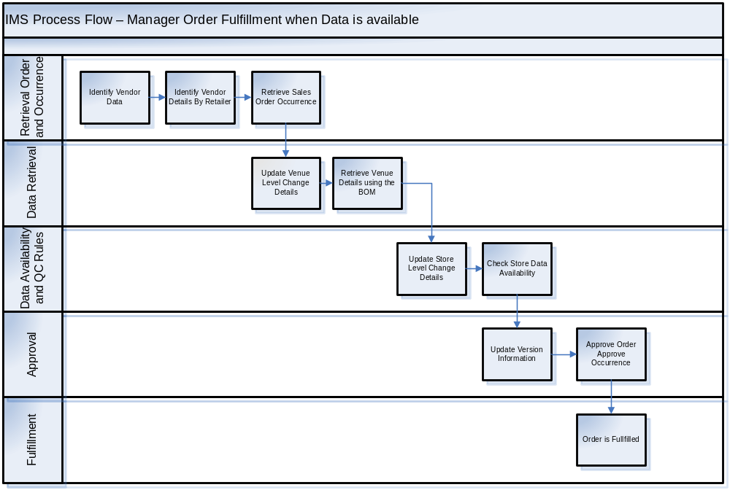

Figure 3: Inventory Management System Detail Flow Diagram

Note: The Use Cases for Place an Order will further defineadditional scenarios. To date these use cases have not been received by the business. For example, the scenarios include when data is not available, when the data that is available is imputed, etc.

IM Record State and Descriptions

IM Service Record States Flow and Resulting States

IM Record may have the following resulting states.

IM Record State | Description
RUN BOM OCCURENCE | The information inputed to IM AE and Processes has been run for an Occurrence (BOM)  Preliminary Conditions:  Data available per Specs without any changes
RUN ORDER | The information inputed to IM AE and Processes has been run for an Order  Preliminary Conditions:  Data available per Specs without any changes
RE RUN BOM OCCURENCE | The information inputted to IM AE and Processes have been rerun for an Occurrence (BOM)  Preliminary Conditions:  No Changes to Specs but changes in the data
RE RUN ORDER | The information inputted to IM AE and Processes have been rerun for the Order  Preliminary Conditions:  No Changes to Specs but changes in the data
UPDATE BOM OCCURENCE | The Results of the IM AE and Processes have been updated for an Occurrence (BOM)  Preliminary Conditions:  Yes Changes to Specs  Yes Back Data submission for history of original order
UPDATE ORDER | The Results of the IM AE and Processes has been fully updated for an Order  Preliminary Conditions:  Yes Changes to Specs  Yes Back Data submission for history of original order
RUN FLEXIBLE RESTATEMENT | The Results of the IM AE and Processes have been partially updated for an Order  Preliminary Conditions:  No Changes to the Specs but changes in the Dimensions or Hierarchies = Partial restatement
ORDER PENDING | The Results from the IM AE and Processes have determined to hold or place order in pending status  Preliminary Conditions:  Usually data is not available but will be available within the order processing window

Note: These resulting states and flows are based on what is currently known. It has been confirmed that an Occurrence is a BOM and that the Order may be a series of Occurrences or BOM’s. It is likely that additional states will be introduced as more is known about back-end processing (i.e. states to account for failed runs for various reasons). It has not been determined if the IM process (what is the status or stage of the IM process) will be tracked.

Appendix
Analytical Engine Method Profile
Name | IM Analytical Engine
Purpose | Calls business rules to determine action needed based on data availability (or the lack of). Releasability Rules and captures results of rule decision trees to release an order
Ownership | IRI – FDW/MetaData Services
Service Used By | Conditions of Use
OMS – IM Component | As part of the Internal processing of the OMS system, the IM AE will be the decision engine to release orders. It is triggered by the presence of a BOM/Order. It invokes the IM Services as needed depending on the preliminary conditions to call the service. Logic to deal with outcome of the call will be handled with rules.
Method Inputs | Input Description
The Specs of an Order/BOM. | The BOM Metadata – ODS
Method Outputs
Boolean value | Receives Yes or No that follows it own internal rule decision tree/matrix depending on Order type and status. Exceptions based on quality of input.

IM Determine Analytics Engine Method Processing

TBD

IM Order Release Service: Venue Group Availability
Service Method Profile
Name | Check Venue Group Availability
Purposes | Check for venue data availability as defined on the order.
Ownership | IRI – FDW/MetaData Services
Service Used By | Conditions of Use
OMS – IM Component | As part of the Order Release-ability Service, this operation is called from the Inventory Management service. Logic to deal with outcome of the call will be handled with rules.
Method Inputs | Input Description
The definition of a venue needed by FDW to determine venue data availability. | The ID of the venue, customer id, time frame, item ids
Method Outputs
Boolean value | Yes or No. Exceptions based on quality of input.

IM Rules Service: Execute Rule
Service Method Profile
Name | Execute Rule
Purposes | Use business rules to determine action needed based on venue data availability (or the lack of).
Ownership | IRI – OMS/BRMS
Service Used By | Conditions of Use
OMS – IM Component | As part of the Order Release-ability Service, this operation is called from the Inventory Management service. Rules defined within the service (hard coded for iteration 1) or retrieved from BRMS will determine answer.
Method Inputs | Input Description
Rules, venue | The rules set id; The venue, time frame, items, customer
Method Outputs
Ultimately a Boolean. There could be logic for delay, retry, or run anyway. | Ultimate outcome with be a yes or no. With no answers, rules need to be defined on what are the next steps.

IM Service: Determine Fact Data Availability
Analytical Engine Method Profile
Name | IM Determine Fact Data Availability
Purposes | Use business rules to determine action needed based on fact data availability (or the lack of).
Ownership | IRI – OMS/BRMS
Service Used By | Conditions of Use
OMS – IM Component | As part of the Order Release-ability Service, this operation is called from the Inventory Management service. Rules defined within the service (hard coded for iteration 1) or retrieved from BRMS will determine answer.
Method Inputs | Input Description
Rules, Fact | The rules set id; The fact data, venue group, time frame, items, customer
Method Outputs
Ultimately a Boolean. There could be logic for delay, retry, or run anyway. | Ultimate outcome with be a yes or no. With no answers, rules need to be defined on what are the next steps.
Purposes | Use business rules to determine action needed based on Fact data availability (or the lack of).

InfoScan MK 1 Limitations:
Given the lack of definition and completion of the back-end processes, in this iteration, this method will only support the OMS rerun functionality. There won’t be any back-end rerun processing.

IM Determine Data Availability Method Processing

TBD

IM Determine Imputation Services

Service Method Profile
Name | IM Determine Imputation
Purposes | Use business rules to determine action needed based on level of imputation and its impact on order releasability
Ownership | IRI – OMS/BRMS
Service Used By | Conditions of Use
OMS – IM Component | As part of the Order Release-ability Service, this operation is called from the Inventory Management service. Rules defined within the service (hard coded for iteration 1) or retrieved from BRMS will determine answer.
Method Inputs | Input Description
Rules, Imputation Level | The rules set id; The fact data ,venue group time frame, items, customer
Method Outputs
Ultimately a Boolean. There could be logic for delay, retry, or run anyway. | Ultimate outcome with be a yes or no. With no answers, rules need to be defined on what are the next steps.
Purposes | Use business rules to determine action needed based on fact data availability and the imputation of the data that is available (or the lack of).

IM Determine Imputation Processing

The IM Creation Service Method will perform the following processing:

- Perform a search for all IM records that have an Order ID equal to the passed Order ID
- For each of these records that have a status of PENDING, the status will be set to CANCELLED

Note: While it would be desirable to recall and cancel IM that have an IN-PROGRESS status, the back-end currently can’t support a cancellation of a IM that is being run. This capability is being given consideration for future iterations..

IM Determine Re Run Method Service

Service Method Profile
Name | IM Determine Re Run Method Process
Purposes | Use business rules to determine action needed based on when the order or BOM needs to be re-run
Ownership | IRI – OMS/BRMS
Service Used By | Conditions of Use
OMS – IM Component | As part of the Order Release-ability Service, this operation is called from the Inventory Management service. Rules defined within the service (hard coded for iteration 1) or retrieved from BRMS will determine answer.
Method Inputs | Input Description
Rules, Impute Level or % and Re Run | The rules set id; The imputation level to high venue, time frame, items, customer
Method Outputs
Ultimately a Boolean. There could be logic for delay, retry, or run anyway. | Ultimate outcome with be a yes or no. With no answers, rules need to be defined on what are the next steps.

IM Determine Re Run Method Processing

TBD
Note: While it would be desirable to recall and cancel IM that have an IN-PROGRESS status, the back-end currently can’t support a cancellation of a IM to BOM that is being run. This capability is being given consideration for future iterations..

IM Service: IM Update Record Method
Service Method Profile
Name | IM Determine Update Record Method Process
Purposes | Use business rules to determine action needed based to update a record and the conditions under which an order is updated.
Ownership | IRI – OMS/BRMS
Service Used By | Conditions of Use
OMS – IM Component | As part of the Order Release-ability Service, this operation is called from the Inventory Management service. Rules defined within the service (hard coded for iteration 1) or retrieved from BRMS will determine answer.
Method Inputs | Input Description
Rules, Update Order | The rules set id; The update order rule, venue, time frame, items, customer
Method Outputs
Ultimately a Boolean. There could be logic for delay, retry, or run anyway. | Ultimate outcome with be a yes or no. With no answers, rules need to be defined on what are the next steps.

IM Update Method Processing

Not enough information is known about the use of this method at this point to specify it. It won’t be used in Iteration 2. It is only noted here as a placeholder for when more details are known.

IM Service: IM Search Method
Service Method Profile
Name | IM Determine Search Record Method Process
Purposes | Use business process to determine action needed based Order or BOM status.
Ownership | IRI – OMS/BRMS
Service Used By | Conditions of Use
OMS – IM Component | As part of the Order Status or Scheduling Service, this operation is called from the Inventory Management service. Rules defined within the service (hard coded for iteration 1) or retrieved from BRMS will determine answer.
Method Inputs | Input Description
Rules, Order BOM Status | The rules set id; The Order and BOM Status
Method Outputs
Ultimately a Boolean. There could be logic for delay, retry, or run anyway. | Ultimate outcome will be the IM process status. This is a place holder for how IM will interface with scheduling. Given the order schedule data in on the Order Record a search service may or may not be needed.

IM Search Method Processing

Not enough information is known about what criteria other processes will need to use to search for IM to specify this method at this time. It is only noted here as a placeholder for when more details are known. The intent of this method is to provide an interface to IM searching which is abstracted from the IM table structure.

IM Scheduling Process

IM Scheduling Engine Processing

The Inventory Management System will be called by the OMS Schedule Engine prompter. Those calls come from the scheduler and will occur at least two time intervals during the order creation lifecycle:

- Order Commit time
- Order Execution time – BOM Occurrence Run

InfoScan MK 1 Limitations:

- Since the Inventory Management functionality is now defined the interface with the BOM Scheduling Engine will need to be defined. The scheduling engine will trigger the state of the BOM if there is unavailable inventory.

- It is envisioned that in the future there will be a need for “run ASAP” orders/BOM which will need to be run as soon as possible and won’t be able to wait for a daily run. The IM – BOM Scheduling Engine Interface will need to support a run “real time” ASAP interface.

IM – Interfaces

IM Interfaces for InfoScan MK 1

The list of interfaces below is not intended to be exhaustive. Some analysis still needs to be done to further define the handles in the IM process internally to OMS.

Interface Delivers | From | TO
Order Specific Details | OMS -BOM | IM
Automate Re Run Process | IM | OMS - BOM
Receives Information About the Data | IM | Meta Data
Information About the Data (Return) | Meta Data | IM
Updates Changes to LOP (Return) | IM | LOP
Display Available Venues | IM | OMS Product Configurator
Retailer Incoming Data Updates | DCS | IM
Calls Rules and Measurements | IM | BRMS
Allows Access to Rules (Returns Answers) | BRMS | IM
N/A for Info Scan MK 1 | IM | Sampling
N/A for Info Scan MK 2 | IM | Projections

Sampling – Applies random and census stratified sampling methods at the chain level and then uses the chain level data to project to market, region and the total US

Projections – Applies projection factors to sample and census data to arrive at chain, market region, and total US level information

IM – Appendix 2
IM Scenarios:
Inventory Management - Order Changes
Data Type | Data Availability and Changes to Data | Key Threshold - Key Values or Parameters to Track and Consider | If Condition met Then Process - Create Order | If Condition Met Then Reprocess - Re Run Order | If Condition Met Then Quit Process -Do Not Create Order | If Condition Met Then Create Partial Order | If Condition is met Update Then Run Order
Dimensional
Venue
Venue Dimension Hierarchy | % of Store Data Not Available
 | % of Store Data Imputed
 | % of Number of Stores Increased
 | % of Number of Stores Decreased
 | % of Stores in Group ACV% Changed
Item
Item Dimension Hierarchy | % of Item Data Not Available
 | % of Item Data Imputed
 | % of Item Data Increased
 | % of Item Data Decreased
Time
Time Dimension Hierarchy | % of Time Parameter Data Not Available
 | Time Parameter for Order includes Future Dates
Consumer
Consumer Dimension Hierarchy | % of Consumer (Group) Data Not Available
OOS
Out of Stock Dimension Hierarchy | % of OOS Data Not Available
Distribution

IM Scenarios (Fulfillment Triggers)
Phase | Product | Scenario | Rules | Data Points
Order Release - InfoScan MK
POS Data
 | Venue | There are 5 suppliers who currently provide data. However, 3 provide data early in the morning and 2 provide data later in the day (at any time) | must release orders as soon as all of the data arrives all of the retailers
 |  |  | must release orders as soon as the data arrives from the first 3 retailers
 |  |  | must release orders by 10:45 AM each day (regardless of completeness of data from first 3 retailers)
 |  |  | must release orders by 11:45 PM each day (regardless of completeness of data from all 5 retailers)
 |  |  | must not impute an entire chain
 |  |  | must provide a window for the first release (10:45 am) to complete before submitting a second order for all 5 retailers IFF their data arrived within 2 hours of first release
Weekly Data | InfoScan | There are N suppliers who currently provide data.
POS + Panel
Venue
Item
Consumer
Measure
POS + Panel + Causal

